1-Page Summary Report

Problem Statement
Estimate the linear relationship between advertising expenditure and sales revenue for a multi-product firm, and (as secondary practice) the marginal propensity to consume from disposable income. The educational goal is to implement simple linear regression both from scratch via gradient descent on squared-error loss and with scikit-learn / closed-form OLS, then explore sensitivity to learning rate, noise and sample size — all framed for economics and business-analytics audiences.

Solution Strategy
1. Explore the advertising–sales scatter. 2. Define SSE loss and derive analytic gradients for slope and intercept. 3. Implement iterative gradient descent with a centering trick for numerical stability. 4. Verify against the normal equations and sklearn LinearRegression. 5. Diagnose residuals and run Monte-Carlo simulations. 6. Estimate a simple Keynesian consumption function (MPC) as additional practice. Audience-aware language is prepared for econometricians, marketing/finance executives, policy analysts and non-specialists.

Solution
Key numerical results (advertising → sales): slope (marginal return) ≈ $2.43k sales per $1k advertising, intercept ≈ $55.6k, R² ≈ 0.55. From-scratch centered GD, closed-form OLS and sklearn agree closely. Residual plots show no strong systematic pattern.
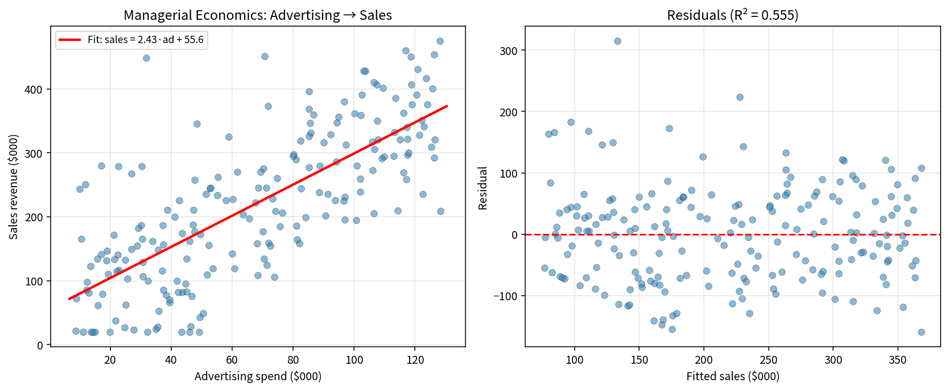
Consumption practice: Estimated MPC ≈ 0.73 (households spend about 73 cents of each extra dollar of disposable income).
Audience translations: Executive — “Each extra $1 000 of advertising is associated with roughly $2 430 of sales; the model explains about 55 % of sales variation.” Policy — “MPC ≈ 0.73.” Non-specialist — a rising line through a cloud of points showing that higher ad budgets tend to go with higher sales.

Key Takeaways
• The line of best fit minimises average squared loss; lower loss is better on the same data.
• Gradient descent moves parameters opposite the loss gradient; learning rate controls step size.
• Centering predictors and response stabilises GD when economic variables have different scales.
• sklearn, closed-form and a correctly implemented GD recover the same simple-OLS coefficients.
• Always adapt charts and language to the audience’s data literacy and subject knowledge (economists vs executives vs non-specialists).
• R² ≈ 0.55 indicates advertising is a useful but incomplete predictor of sales; other factors remain.

